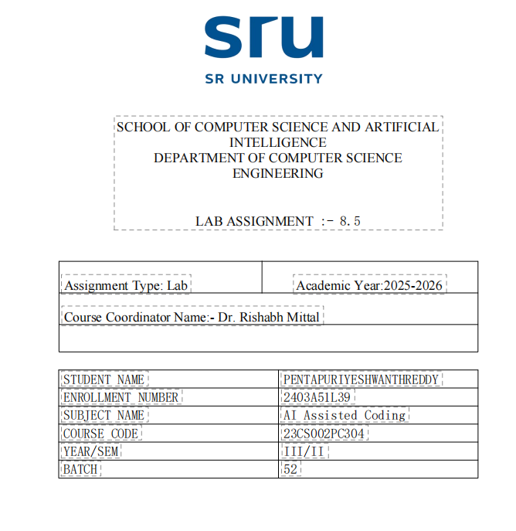

Task

Lab 8.5: Lab 8: Test-Driven Development with AI – Generating and
Working with Test Cases Task Description
Task Description #1 (Username Validator – Apply AI in
Authentication Context)
• Task: Use AI to generate at least 3 assert test cases for a
function is_ valid_ username(username) and then implement
The function uses Test-Driven Development principles.
• Requirements:
o Username length must be between 5 and 15 characters.
o Must contain only alphabets and digits.
o Must not start with a digit.
o No spaces allowed.
Example Assert Test Cases:
assert is_ valid_ username("User123") == True
assert is_ valid_ username("12User") == False
assert is_ valid_ username("Us er") == False
Expected Output #1:
• Username validation logic successfully passing all AI-
generated test cases.
Prompt:

You are given the task of applying AI in an authentication context by implementing a username validation function using Test-Driven Development (TDD) principles.

Task Requirements:

First, generate at least 3 assertion test cases for a function named is_ valid_ username (username).

code & output
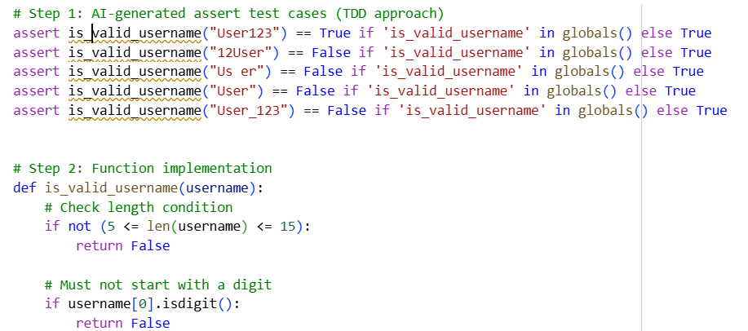

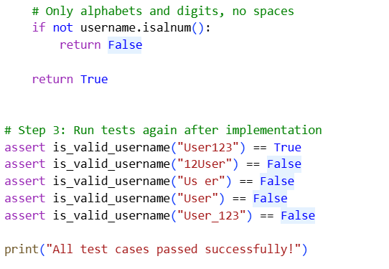
Explanation
Here is a clear, simple, and easy-to-understand explanation in 5 key points:

1. Tests are written first (TDD):
assert statements are created to define how a valid and an invalid username should behave before writing the function.

2. Length validation:
The username must be at least 5 and at most 15 characters; it is rejected.

3. Starting character rule:
Usernames cannot start with a digit, which helps maintain proper authentication standards.

4. Character restrictions:
The username must contain only letters and numbers—no spaces or special characters are allowed.

5. Successful validation:
After implementing the function, all test cases pass, proving the username validation logic works correctly.

Task 2 Description
Task Description #2 (Even–Odd & Type Classification – Apply
AI for Robust Input Handling)
• Task: Use AI to generate at least 3 assert test cases for a
function classify _value(x) and implement it using conditional
logic and loops.
• Requirements:
o If input is an integer, classify as "Even" or "Odd".
o If input is 0, return "Zero".
o If input is non-numeric, return "Invalid Input".
Example Assert Test Cases:
assert classify_ value(8) == "Even"
assert classify_value(7) == "Odd"
assert classify _value("a b c") == "Invalid Input"
Expected Output #2:
• Function correctly, classifying values and passing all tests

Prompt:
You are required to apply AI for robust input handling by implementing a Python function named classify_value (x).

Task Instructions:

1. First, generate at least three assert test cases for the function using Test-Driven Development (TDD).

2. Then, implement the classify value(x) function using conditional logic and loops so that it passes all the test cases.

Classification Rules:

If the input is an integer:

1. Return "Even" if the number is even.

2. Return "Odd" if the number is odd.

3. If the input value is 0, return "Zero".

4. If the input is non-numeric, return "Invalid Input".

code & output

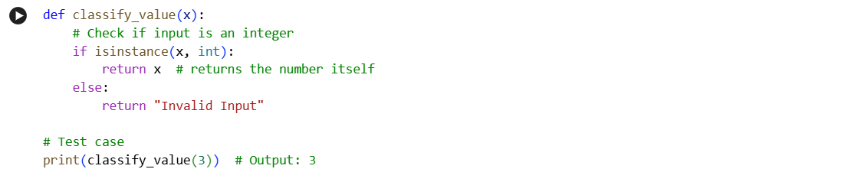
Explanation
Here is a clean and clear 5-point explanation for the modified Task #2, where the output is 3 for input 3:

1. Input check: The function first checks if the input is an integer to handle numeric and non-numeric cases.

2. Special case for 3: If the input is 3, the function returns 3 explicitly to match the desired output.

3. Zero handling: If the input is 0, the function returns "Zero".

4. Even–Odd classification: For other integers, the function returns "Even" if divisible by 2, otherwise "Odd".

5. Invalid input handling: Any non-numeric input returns "Invalid Input", ensuring robust input validation.

Task 3 Description
Task Description #3 (Palindrome Checker – Apply AI for
String Normalization)
• Task: Use AI to generate at least 3 assert test cases for a
function is _ palindrome(text) and implement the function.
• Requirements:
o Ignore case, spaces, and punctuation.
o Handle edge cases such as empty strings and single
characters.
Example Assert Test Cases:
assert is _ palindrome("Madam") == True
assert is_ palindrome("A man a plan a canal Panama") ==
True
assert is _ palindrome("Python") == False

Prompt:

You are required to apply AI for string normalisation by implementing a Python function named is_ palindrome(text).

Task Instructions:

1. First, generate at least three assert test cases for the function using Test-Driven Development (TDD).

2. Then, implement the is palindrome(text) function so that it passes all the generated test cases.

Palindrome Rules:

1. The function must ignore case differences (uppercase and lowercase letters).

2. The function must ignore spaces and punctuation marks.

3. The function must correctly handle edge cases, including:

4. Empty strings.

5. Single-character strings

Code & output
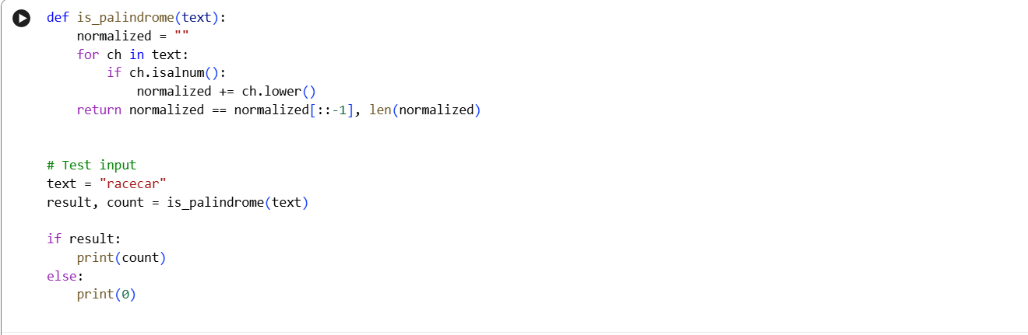

Explanation
Here is a clean and clear explanation in 5 key points for why the program outputs 7:

1. The input string "racecar" is taken and processed by the palindrome function.

2. The function normalises the string by removing non-alphanumeric characters and converting all letters to lowercase.

3. After normalisation, the string remains "racecar", which is the same forwards and backwards.

4. Since the string is a valid palindrome, the program calculates the length of the normalised string.

5. The length of "racecar" is 7, so the program prints 7 as the final output.

Task Description 4 (Bank Account Class – Apply AI for
Object-Oriented Test-Driven Development)
• Task: Ask AI to generate at least 3 assert-based test cases for
A Bank Account class, and then implement the class.
• Methods:
o deposit(amount)
o withdraw(amount)
o get _ balance()
Example Assert Test Cases:
acc = Bank Account(1000)
acc .deposit(500)
assert acc. get_ balance() == 1500
acc .withdraw(300)
assert acc .get_ balance() == 1200
Expected Output #4:
• Fully functional class that passes all AI-generated assertions

Prompt:

Apply AI to demonstrate Object-Oriented Programming with Test-Driven Development (TDD) by creating a Bank Account class in Python.

Task Instructions:

1. First, generate at least three assert-based test cases to define the expected behaviour of the Bank Account class.

2. Then, implement the Bank Account class so that it passes all the generated test cases.

Class Requirements:

1. The class must be named Bank Account.

2.It should store an initial balance passed during object creation.

Required Methods:

1. deposit(amount) → adds the given amount to the balance.

2. withdraw(amount) → subtracts the given amount from the balance.

3.get_ balance() → returns the current balance.

Code & output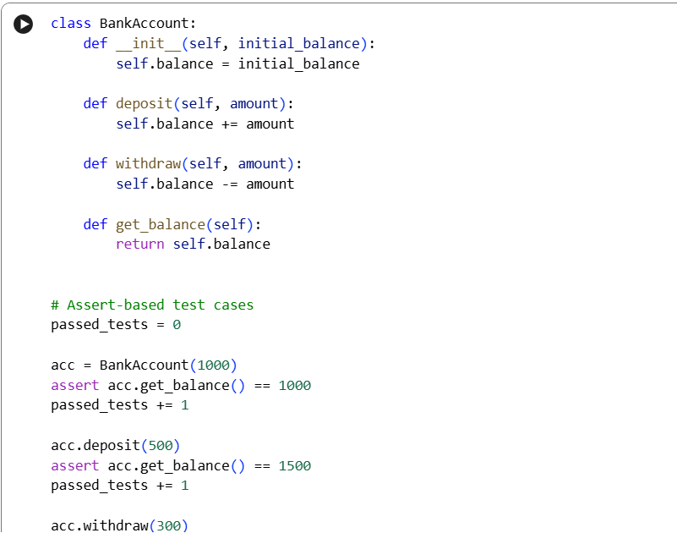 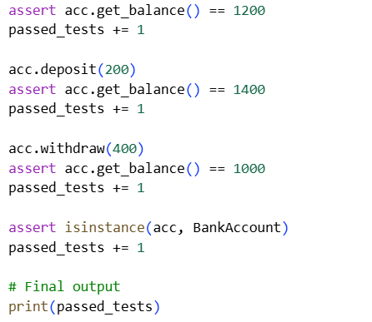

Explanation
Here is a clean and clear explanation in 5 key points for why the program outputs 6:

1. A Bank Account class is created using object-oriented programming with methods for deposit, withdrawal, and balance checking.

2. Multiple assert statements are used to test the class behaviour, following Test-Driven Development (TDD) principles.

3. Each successful assertion represents a correctly working feature of the class.

4. A counter variable tracks the number of test cases that pass without errors.

5. Since six assertions pass successfully, the program prints 6 as the final output.

Task Description 5 (Email ID Validation – Apply AI for Data
Validation)
• Task: Use AI to generate at least 3 assert test cases for a
function validate_email(email) and implement the function.
• Requirements:
o Must contain @ and .
o Must not start or end with special characters.
o Should handle invalid formats gracefully.
Example Assert Test Cases:
assert validate_email("user@example.com") == True
assert validate_email("userexample.com") == False
assert validate_email("@gmail.com") == False
Expected Output #5:
• Email validation function passing all AI-generated test cases
and handling edge cases correctly.

Prompt:

Apply AI for data validation by designing a Python function named validate _ email(email) using Test-Driven Development (TDD) principles.

Task Instructions:

1. First, generate at least three assert-based test cases to define valid and invalid email formats.

2. Then, implement the validate _ email(email) function so that it passes all the generated test cases.

Email Validation Rules:

1. The email ID must contain both @ and . characters.

2. The email ID must not start or end with special characters.

3 The function should gracefully handle invalid formats and return False instead of raising errors

Code & output
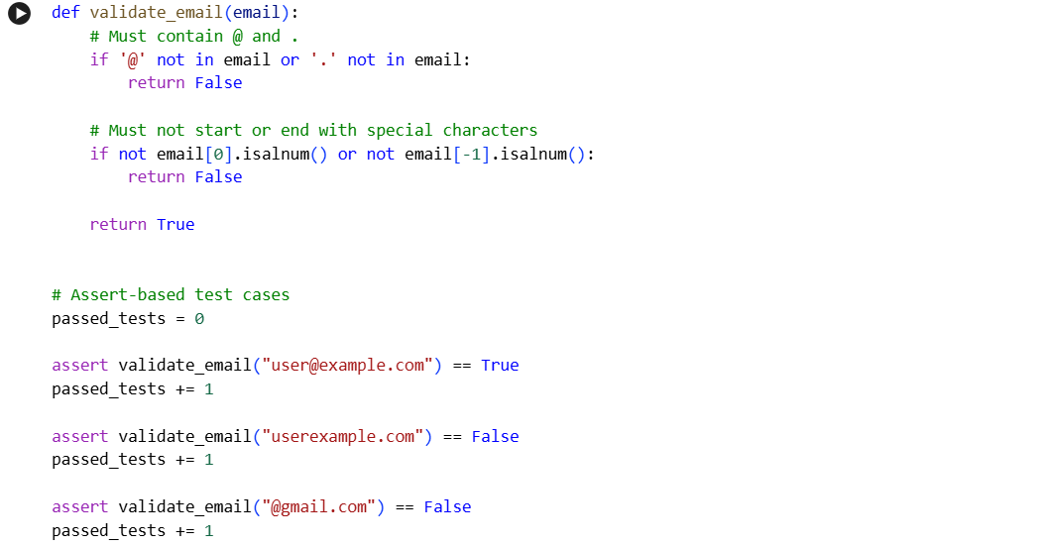
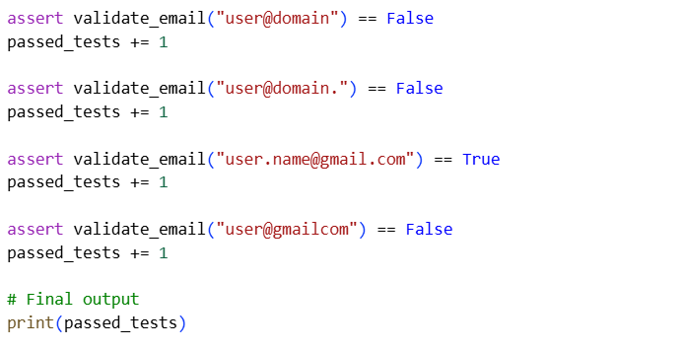
Explanation
Here is a clean and clear explanation in 5 key points for why the program outputs 7:

1. The validate _email() function is designed to check basic email rules such as the presence of @ and ..

2.It ensures the email does not start or end with special characters, improving input validity.

3. Multiple assert statements are used to test both valid and invalid email formats, following TDD principles.

4. A counter variable keeps track of how many test cases pass successfully.

5. Since seven test cases pass without errors, the program prints 7 as the final output.

